**ResNet50**

* **Model**: ResNet50 used as the base model, with transfer learning and fine-tuning to classify coral images into Bleached and Healthy.

**Below are the details for the training model**

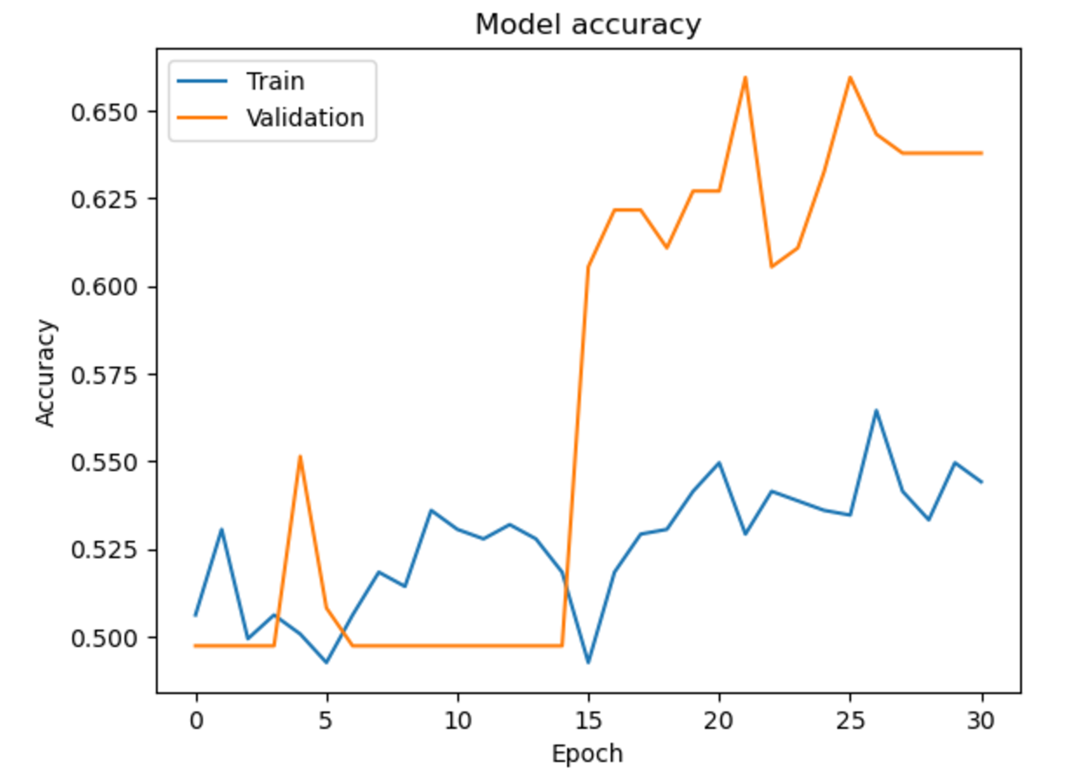 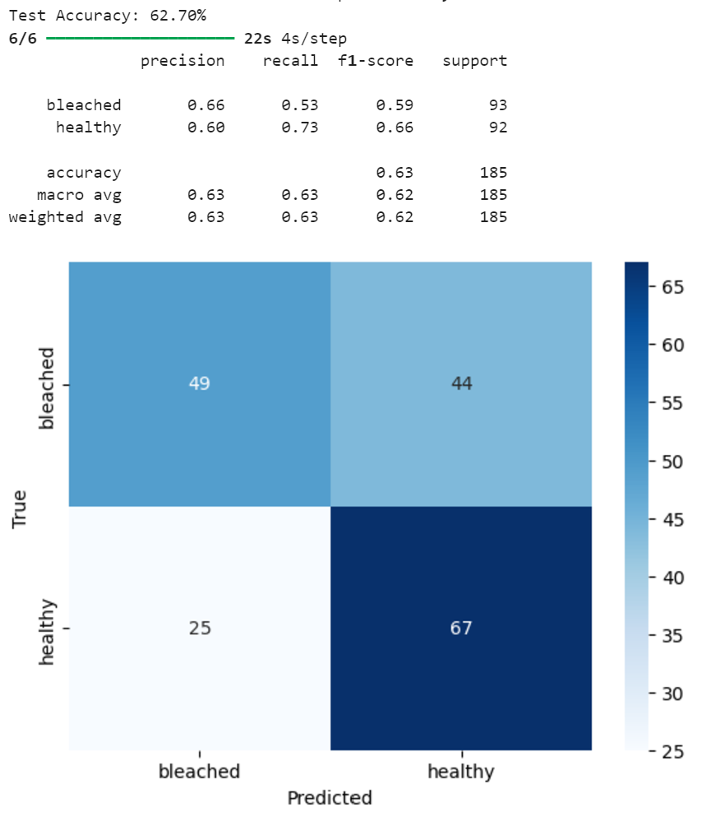

* **Test Accuracy**: Moderate Performance the accuracy was approximately **62.7%**,
* **Confusion Matrix**: Healthy class has a better recall (0.73) compared to the Bleached class (0.53).
* **Precision, Recall, and F1-Score**: Healthy class has a better Recall (0.73), but the Bleached class has better Precision(0.66). This model struggles with imbalance between the two categories and feature extraction.
* **Model Accuracy:** Validation accuracy is higher than training accuracy, indicating overfitting or insufficient training of the base model.

**Challenges:**

1. **Data Augmentation Issues:** Because of noise caused by Aggressive augmentation, the model's ability to learn clear patterns is reduced.

Horizontal flipping might not be applicable to coral images due to their natural orientation.

**Improvements:**

* Avoid using Shear function as the Shearing can impact corals structures as the corals are texture and colour sensitive data.
* Smaller rotation range(10-15) instead of 20 avoids and using mild zoom(0.1) instead of 0.2 prevents excessive distortion.

1. **Training validation Problems:** Validation accuracy is way more than the training accuracy, because of augmented noisy inputs during training (rotations, shifts, zooms, shears)

**Improvements:**

* Improve preprocessing by applying noise reduction (Gaussian Blur) to augmented data to reduce distortions.
* Use smaller batch sizes (16 instead of 32). Smaller batch reduce noise improving the stability.

1. **Impact of Freezing Layers:** As all layers of the ResNet50 model remain frozen, and no fine-tuning is actually performed.

**Improvements:**

* Unfreeze layers so that the model adapts gradually and fine tuning more layers.
* By adding L2 Regularization to the model, prevents overfitting of data.

**Conclusion:**

* Analyse the importance of Unfreezing Layers and by fine tuning of layers the model can improve the classification accuracy.
* Additionally the need for advanced preprocessing techniques like noise reduction, data augmentation to enhance the robustness of the model.
* Using Batch Normalization could resulted in more stable training, and better dealing with noisy data, generalization due to the regularizing effect.